INTRODUCTION:
overview
if you run advertising campaigns on YouTube, then you know how important it is to place a promotional piece in YouTube content on a channel with an engaged, authentic audience, and regularly receive a certain number of views from your content partner. So you need to carefully audit the YouTube channel of those creators you have chosen as your primary candidates.

purpose of my project
On this section, you can carry out a thorough analysis of your videos and see how your users have reached your videos.

On the first graph, you can check your impressions (how many times people have seen an impression of your videos across YouTube), impressions click-through rate, views and unique viewers.

Below, you can find valuable information about where users found your YouTube videos, that is, the traffic source.

If viewers access your video from an external source, from YouTube searches or suggested videos, amongst others.

PROBLEM DEFINITION & DESIGN THINKING
empathy map
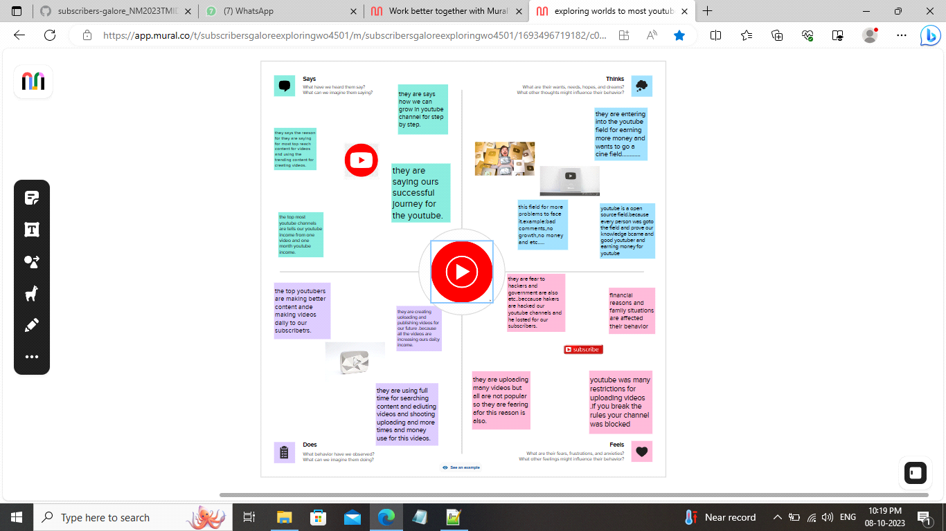
ideation & brain storming map
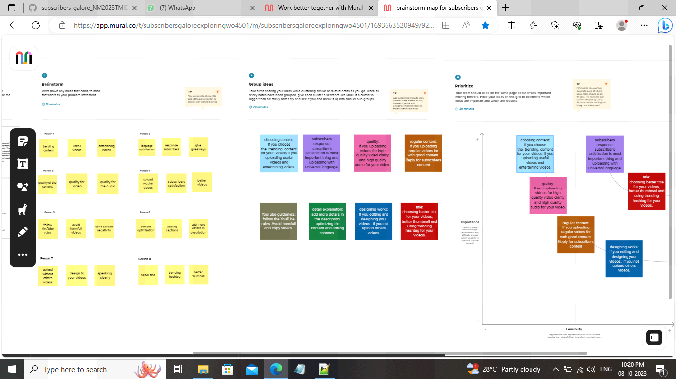
RESULT:
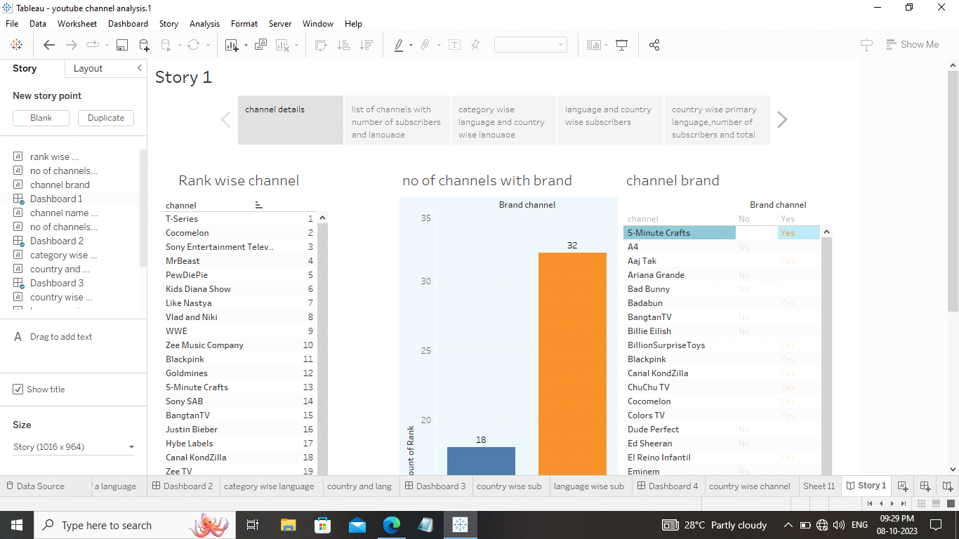
ADVANTAGES & DISADVANTAGES
advantages
Understand the demographics of your viewers, such as their age and location.
Determine how long viewers have watched your videos.
Identify the sources of traffic to your videos.
Plan a better YouTube strategy for growing your channel.
Discover any inauthentic activity on a chosen YouTube channel.
Check whether you’d desire to invest in a certain candidate or not via YouTube Analytics.
Critically assess the past, present and future of Youtube to identify gaps and loopholes between the present and the future, direct Youtube towards filling those loopholes through correct resource allocation, help idea generation for enhancing business performance, and allow strategic decision making for fueling business growth.
Check how well your videos are performing and where you can tweak your content.
Use valuable data to increase views.

disadvantages
this project youtube channel analysis for not including all the channels in the youtube its contain only worlds top most 50 youtube channels.
this project was made in only english language so all country peoples are not understand this.
APPLICATIONS
you can use analytics to better understand your video and channel performance with key metrics and reports in YouTube Studio.
Youtube channels analysis is using for top most youtube channels for analise the data.

CONCLUSION
So this is my project youtube channel analysis.i my finished my project with my team members support.
My project was based on worlds top most youtube channels.
conclusion YouTube channel analysis is essential for understanding your audience’s behaviour, tracking your progress, and making data-driven decisions to optimize your content. However, it’s important to avoid the seven major errors discussed above to get a comprehensive view of your channel’s performance.

FUTURE SCOPE:
You can access all the primary-level analytics that can help you analyze how your content is performing. You can also generate interaction reports, watch time reports, and earn reports using YouTube Studio. All these reports help you analyze your channel and even individual videos.

